Online shopping, banking, charity and travel
The Internet has had an enormous impact on the way people shop, do their banking, make investments, plan travel, and even how they pay their taxes. In the vast majority of cases, the experiences have been positive. Online shopping allows you to find items — which are sometimes hard or impossible to find in local stores — and typically get the lowest possible price by comparing prices with a variety of merchants. Yes, there are risks associated with shopping online, but they can be managed. Besides, there are also risks associated with driving to a store to make purchases.
Online banking and investing is another great convenience. With a click of a mouse or a touch of a smartphone, you can transfer money between accounts, pay bills, and make investments.
Stay safe tips
Use strong and unique passwords.
- Strong passwords are essential, just as they are with email and social media accounts.
- Never share your passwords with anyone, unless you have designated someone you trust to manage your accounts.
- Make sure your passwords have at least eight characters.
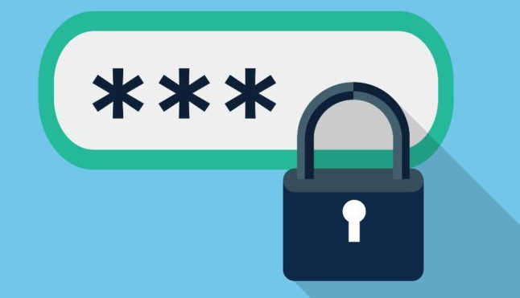
  - Include numbers, upper and lower case letters, and symbols, and do not use names or dictionary words.

Don’t click on links
- Don’t click on links from emails or on social media from banks, credit card companies, government agencies, or other organizations, unless you’re 100% certain they are legitimate.
- There is a common scam, called phishing, where someone sends you a link to what looks like a legitimate website, but it’s actually a scam site created by criminals to steal your login or other personal information.
- Even if the company name is part of the Web address, it could still be a scam.
- Your safest bet is to type in the Web address like you normally do and if in doubt, call the organization.

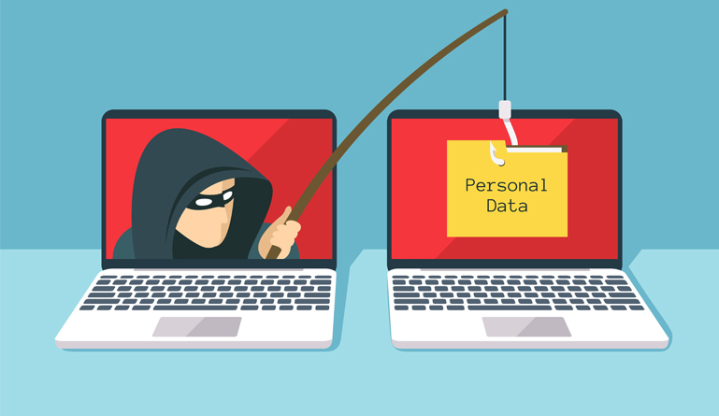

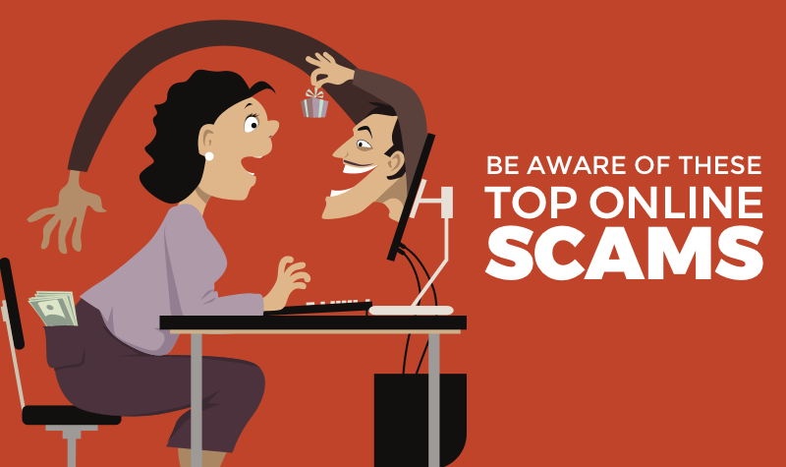
Be wary of any offer that’s too good to be true
- For example, being told you’ve won a contest that you didn’t enter, or you’re being offered an incredible price on a vacation or product way below what you’d expect to pay.

Only shop at reputable online merchants.
- Be careful about any online merchant that you have never heard of.
- Many are legitimate but some might be out to steal your credit card number or other financial information, or simply fail to deliver what you’ve paid for.
When shopping or banking look for secure websites
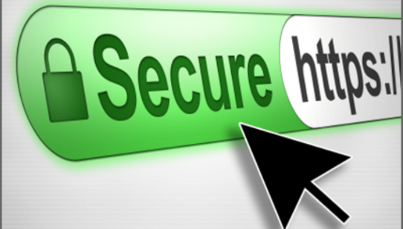
- With an https in the browser’s address bar. The “s” stands for “secure.” If it’s just http, it’s not a secure site.
- If you shop or bank using a mobile app, be sure it was issued by that company.
- Look for reviews from others or ask an expert if you’re not sure.

Use credit cards if possible
- Otherwise use debit cards or safe online payment services, such as Paypal.
- NEVER SEND CASH, CASHIER’S CHEQUES, OR MONEY ORDERS. Even sending a personal cheque can be dangerous.
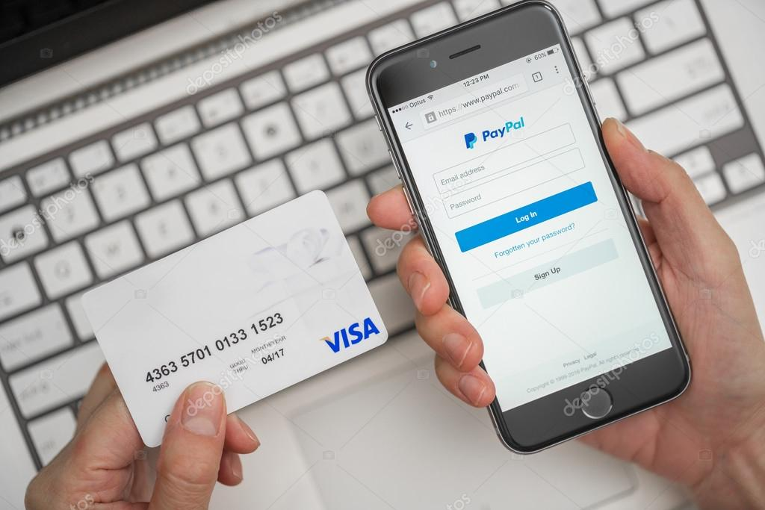
- It’s best to use a credit card because, if there is a dispute, the credit card company will stop the charge or refund your money while they investigate your claim.
- Debit cards also have protections but sometimes you have to wait to get your money back.
- Services like Paypal, Android Pay, and Apple Pay also have some protections but credit cards are still the best bet.

Be careful before you click.
- There are certain things that you may not be able to undo, buying a non-refundable flight or hotel room - Carefully review all transactions before confirming them. If you do make a mistake contact the company right away to see if it’s possible to undo it.
- Many online merchants have a cancelation feature that lets you back out of a purchase, but you must do so promptly.
- Once an item is ready to be shipped it may be too late to cancel the order. You can often return your purchases, but you’re likely to have to pay for return shipping.
- Make sure you understand the return policies from online merchants and know all of the charges, including shipping, handling fees, and taxes.
Do some research before donating to online causes.
- Crowd-funding sites like Kickstarter, Indiegogo, and GoFundMe are great places to be among the first supporters or purchasers of new products, donate to worthy causes and organizations, and even provide financial support for people with a compelling need, but you should proceed with caution.
- Read all the fine print and do a little research on the person or organization behind the pitch.
- If they’re raising money for a cause, try to find out if it’s real, and if they are launching a cool new product, make sure their pitch is realistic.

Protect against identity theft.
- Unless you’re sure it’s a legitimate site, avoid posting your full birth date and place of birth, and be cautious when asked to enter any other personal information, such as your home address.
- Legitimate media sites like Facebook and financial institutions may be required to ask for your date of birth.
- Only disclose credit card numbers to legitimate online merchants.
- When in doubt, do some research to see what other people say about them.

Monitor your online financial accounts.
- Look for recent activity to be sure that there are no fraudulent charges to your credit, debit, or bank accounts.
- If you find something suspicious, report it right away to the financial institution’s fraud department or the toll free number on your credit or debit card. Even if you don’t bank online, there is still a risk that you could be a victim of fraud.
- Let the institution know right away if there is an issue.
- In most cases you are protected against fraud but you must report it.

